1. Online Library Management System
Aim
To design and develop an online library management system that allows students to register, log in, search for books and study materials, view borrowing history, check fines, and download materials. The librarian can manage books, issue and return books, calculate fines, and maintain study materials.
Algorithm
- Start the application.
- Allow students and librarians to log in using valid credentials.
- Allow new students to register.
- Enable users to search for books and study materials by year and semester.
- Display book details and material information.
- Allow students to view borrowing history, issue dates, due dates, and fines.
- Allow students to download available study materials.
- Allow the librarian to add, update, and delete book details.
- Allow the librarian to issue and return books and update their status.
- Calculate fines for overdue books.
- Allow the librarian to upload and manage study materials.
- Stop.

Code :
<!DOCTYPE html>
<html lang="en">
<head>
<meta charset="UTF-8">
<meta name="viewport" content="width=device-width, initial-scale=1.0">
<title>Library Management System</title>

<style>
* {
box-sizing: border-box;
margin: 0;
padding: 0;
font-family: Arial, sans-serif;
}

body {
background: #f4f6f8;
color: #222;
}

header {
background: #263238;
color: white;
padding: 18px 40px;
display: flex;
justify-content: space-between;
align-items: center;
}

header h1 {
font-size: 24px;
}

nav button {
background: transparent;
color: white;
border: none;
margin: 5px;
padding: 8px 12px;
cursor: pointer;
}

nav button:hover {
background: #455a64;
border-radius: 5px;
}

.container {
width: 90%;
max-width: 1200px;
margin: 30px auto;
}

.section {
display: none;
}

.active {
display: block;
}

.hero {
background: #607d8b;
color: white;
padding: 60px 30px;
text-align: center;
border-radius: 10px;
}

.hero h2 {
font-size: 35px;
margin-bottom: 15px;
}

.hero p {
font-size: 18px;
}

.card-container {
display: flex;
gap: 20px;
flex-wrap: wrap;
margin-top: 25px;
}

.card {
background: white;
padding: 25px;
border-radius: 10px;
box-shadow: 0 2px 8px #ccc;
flex: 1;
min-width: 220px;
}

.card h3 {
margin-bottom: 10px;
color: #37474f;
}

.form-box {
background: white;
padding: 25px;
max-width: 600px;
margin: auto;
border-radius: 10px;
box-shadow: 0 2px 8px #ccc;
}

.form-box h2 {
margin-bottom: 20px;
}

input, select, textarea {
width: 100%;
padding: 11px;
margin: 8px 0 15px;
border: 1px solid #bbb;
border-radius: 5px;
}

button.action {
background: #37474f;
color: white;
padding: 11px 18px;
border: none;
border-radius: 5px;
cursor: pointer;
}

button.action:hover {
background: #546e7a;
}

.search-box {
background: white;
padding: 20px;
margin: 20px 0;
border-radius: 10px;
box-shadow: 0 2px 8px #ddd;
}

table {
width: 100%;
border-collapse: collapse;
background: white;
margin-top: 20px;
}

th, td {
padding: 12px;
border: 1px solid #ddd;
text-align: center;
}

th {
background: #37474f;
color: white;
}

footer {
margin-top: 40px;
background: #263238;
color: white;
text-align: center;
padding: 20px;
}
</style>
</head>

<body>

<header>
<h1>📚 Library Management System</h1>

<nav>
<button onclick="showSection('home')">Home</button>
<button onclick="showSection('books')">Books</button>
<button onclick="showSection('login')">Login</button>
<button onclick="showSection('register')">Register</button>
<button onclick="showSection('student')">Student</button>
<button onclick="showSection('admin')">Admin</button>
<button onclick="showSection('material')">Materials</button>
<button onclick="showSection('contact')">Contact</button>
</nav>
</header>

<div class="container">

<!-- HOME -->
<section id="home" class="section active">

<div class="hero">
<h2>Welcome to Our Library</h2>
<p>Search, borrow and manage your books and study materials easily.</p>
<br>
<button class="action" onclick="showSection('books')">
Search Books
</button>
</div>

<div class="card-container">

<div class="card">
<h3>📖 Search Books</h3>
<p>Find books by title, author or category.</p>
</div>

<div class="card">
<h3>👨‍🎓 Student Account</h3>
<p>View borrowed books, due dates and fines.</p>
</div>

<div class="card">
<h3>👨‍💼 Admin Panel</h3>
<p>Manage books, students, issues and returns.</p>
</div>

<div class="card">
<h3>📚 Study Materials</h3>
<p>Search and download semester-wise materials.</p>
</div>

</div>

</section>

<!-- BOOKS -->
<section id="books" class="section">

<h2>📖 Book Catalog</h2>

<div class="search-box">

<input type="text"
id="bookSearch"
placeholder="Search by book title, author or category..."
onkeyup="searchBooks()">

</div>

<table id="bookTable">

<tr>
<th>ID</th>
<th>Book Name</th>
<th>Author</th>
<th>Category</th>
<th>Status</th>
</tr>

<tr>
<td>101</td>
<td>Python Programming</td>
<td>Guido van Rossum</td>
<td>Programming</td>
<td>Available</td>
</tr>

<tr>
<td>102</td>
<td>Machine Learning</td>
<td>Tom Mitchell</td>
<td>AI/ML</td>
<td>Available</td>
</tr>

<tr>
<td>103</td>
<td>Database Systems</td>
<td>Raghu Ramakrishnan</td>
<td>Database</td>
<td>Issued</td>
</tr>

<tr>
<td>104</td>
<td>Computer Networks</td>
<td>Andrew S. Tanenbaum</td>
<td>Networking</td>
<td>Available</td>
</tr>

<tr>
<td>105</td>
<td>Web Technologies</td>
<td>Robert W. Sebesta</td>
<td>Web Development</td>
<td>Available</td>
</tr>

</table>

</section>

<!-- LOGIN -->
<section id="login" class="section">

<div class="form-box">

<h2>🔐 Login</h2>

<label>Email</label>
<input type="email" id="loginEmail" placeholder="Enter email">

<label>Password</label>
<input type="password" id="loginPassword" placeholder="Enter password">

<select id="loginRole">
<option>Student</option>
<option>Admin</option>
</select>

<button class="action" onclick="login()">
Login
</button>

</div>

</section>

<!-- REGISTER -->
<section id="register" class="section">

<div class="form-box">

<h2>📝 Student Registration</h2>

<label>Full Name</label>
<input type="text" id="regName" placeholder="Enter full name">

<label>Email</label>
<input type="email" id="regEmail" placeholder="Enter email">

<label>Phone</label>
<input type="text" id="regPhone" placeholder="Enter phone number">

<label>Password</label>
<input type="password" id="regPassword" placeholder="Create password">

<button class="action" onclick="registerUser()">
Register
</button>

</div>

</section>

<!-- STUDENT -->
<section id="student" class="section">

<h2>👨‍🎓 Student Dashboard</h2>

<div class="card-container">

<div class="card">
<h3>My Profile</h3>
<p>Name: Student User</p>
<p>Email: student@gmail.com</p>
</div>

<div class="card">
<h3>Borrowed Books</h3>
<p>Currently Borrowed: 2</p>
</div>

<div class="card">
<h3>Fine</h3>
<p>Current Fine: ₹50</p>
</div>

</div>

<h3 style="margin-top:30px;">📚 My Borrow History</h3>

<table>

<tr>
<th>Book</th>
<th>Issue Date</th>
<th>Expected Return</th>
<th>Status</th>
<th>Fine</th>
</tr>

<tr>
<td>Python Programming</td>
<td>20-09-2026</td>
<td>05-10-2026</td>
<td>Borrowed</td>
<td>₹0</td>
</tr>

<tr>
<td>Machine Learning</td>
<td>15-09-2026</td>
<td>30-09-2026</td>
<td>Returned</td>
<td>₹50</td>
</tr>

</table>

</section>

<!-- ADMIN -->
<section id="admin" class="section">

<h2>👨‍💼 Admin Dashboard</h2>

<div class="card-container">

<div class="card">
<h3>Total Books</h3>
<p>1,250</p>
</div>

<div class="card">
<h3>Issued Books</h3>
<p>320</p>
</div>

<div class="card">
<h3>Students</h3>
<p>450</p>
</div>

<div class="card">
<h3>Pending Returns</h3>
<p>25</p>
</div>

</div>

<h3 style="margin-top:30px;">Manage Books</h3>

<table>

<tr>
<th>Book ID</th>
<th>Book Name</th>
<th>Author</th>
<th>Year</th>
<th>Action</th>
</tr>

<tr>
<td>101</td>
<td>Python Programming</td>
<td>Guido van Rossum</td>
<td>2024</td>
<td>
<button class="action" onclick="editBook()">
Edit
</button>
<button class="action" onclick="deleteBook()">
Delete
</button>
</td>
</tr>

<tr>
<td>102</td>
<td>Machine Learning</td>
<td>Tom Mitchell</td>
<td>2023</td>
<td>
<button class="action" onclick="editBook()">
Edit
</button>
<button class="action" onclick="deleteBook()">
Delete
</button>
</td>
</tr>

</table>

<br>

<button class="action" onclick="addBook()">
+ Add New Book
</button>

</section>

<!-- MATERIAL -->
<section id="material" class="section">

<h2>📚 Study Materials</h2>

<div class="search-box">

<select id="materialYear">
<option value="">Select Year</option>
<option>1st Year</option>
<option>2nd Year</option>
<option>3rd Year</option>
<option>4th Year</option>
</select>

<select id="semester">
<option value="">Select Semester</option>
<option>Semester 1</option>
<option>Semester 2</option>
<option>Semester 3</option>
<option>Semester 4</option>
<option>Semester 5</option>
<option>Semester 6</option>
<option>Semester 7</option>
<option>Semester 8</option>
</select>

<button class="action" onclick="searchMaterial()">
Search Material
</button>

</div>

<table>

<tr>
<th>Material</th>
<th>Year</th>
<th>Semester</th>
<th>Action</th>
</tr>

<tr>
<td>Machine Learning Notes</td>
<td>3rd Year</td>
<td>Semester 5</td>
<td>
<button class="action"
onclick="downloadMaterial('Machine Learning Notes')">
Download
</button>
</td>
</tr>

<tr>
<td>Database Management Notes</td>
<td>2nd Year</td>
<td>Semester 4</td>
<td>
<button class="action"
onclick="downloadMaterial('Database Management Notes')">
Download
</button>
</td>
</tr>

<tr>
<td>Computer Networks Notes</td>
<td>3rd Year</td>
<td>Semester 5</td>
<td>
<button class="action"
onclick="downloadMaterial('Computer Networks Notes')">
Download
</button>
</td>
</tr>

</table>

</section>

<!-- CONTACT -->
<section id="contact" class="section">

<div class="form-box">

<h2>📞 Contact Us</h2>

<label>Name</label>
<input type="text" id="contactName">

<label>Email</label>
<input type="email" id="contactEmail">

<label>Message</label>
<textarea id="contactMessage" rows="5"></textarea>

<button class="action" onclick="sendMessage()">
Send Message
</button>

</div>

</section>

</div>

<footer>
<p>© 2026 Library Management System | All Rights Reserved</p>
</footer>

<script>

/* SHOW SECTIONS */

function showSection(sectionId) {

let sections = document.querySelectorAll(".section");

sections.forEach(function(section) {
section.classList.remove("active");
});

document.getElementById(sectionId).classList.add("active");

window.scrollTo(0, 0);
}

/* BOOK SEARCH */

function searchBooks() {

let input = document.getElementById("bookSearch");
let filter = input.value.toLowerCase();

let table = document.getElementById("bookTable");
let rows = table.getElementsByTagName("tr");

for (let i = 1; i < rows.length; i++) {

let text = rows[i].innerText.toLowerCase();

if (text.includes(filter)) {
rows[i].style.display = "";
} else {
rows[i].style.display = "none";
}
}
}

/* LOGIN */

function login() {

let email = document.getElementById("loginEmail").value;
let password = document.getElementById("loginPassword").value;
let role = document.getElementById("loginRole").value;

if (email === "" || password === "") {

alert("Please enter email and password.");
return;
}

alert(role + " login successful!");

if (role === "Admin") {
showSection("admin");
} else {
showSection("student");
}
}

/* REGISTER */

function registerUser() {

let name = document.getElementById("regName").value;
let email = document.getElementById("regEmail").value;
let phone = document.getElementById("regPhone").value;
let password = document.getElementById("regPassword").value;

if (name === "" ||
email === "" ||
phone === "" ||
password === "") {

alert("Please fill all fields.");
return;
}

alert("Registration successful!");

showSection("login");
}

/* ADMIN */

function addBook() {

let book = prompt("Enter new book name:");

if (book) {
alert(book + " added successfully!");
}
}

function editBook() {

alert("Book details can be edited here.");
}

function deleteBook() {

let result = confirm("Are you sure you want to delete this book?");

if (result) {
alert("Book deleted successfully.");
}
}

/* MATERIAL SEARCH */

function searchMaterial() {

let year = document.getElementById("materialYear").value;
let semester = document.getElementById("semester").value;

if (year === "" || semester === "") {

alert("Please select year and semester.");
return;
}

alert(
"Searching materials for " +
year + " - " +
semester
);
}

/* DOWNLOAD */

function downloadMaterial(name) {

alert(
"Downloading: " +
name
);
}

/* CONTACT */

function sendMessage() {

let name = document.getElementById("contactName").value;
let email = document.getElementById("contactEmail").value;
let message = document.getElementById("contactMessage").value;

if (name === "" ||
email === "" ||
message === "") {

alert("Please fill all fields.");
return;
}

alert("Your message has been sent successfully!");

}

</script>

</body>
</html>

Output :
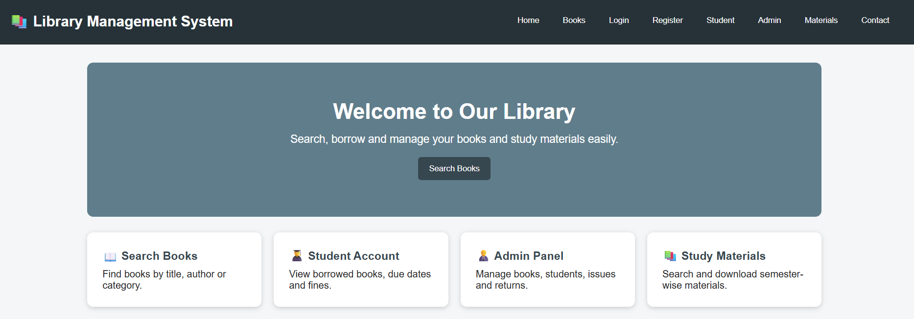
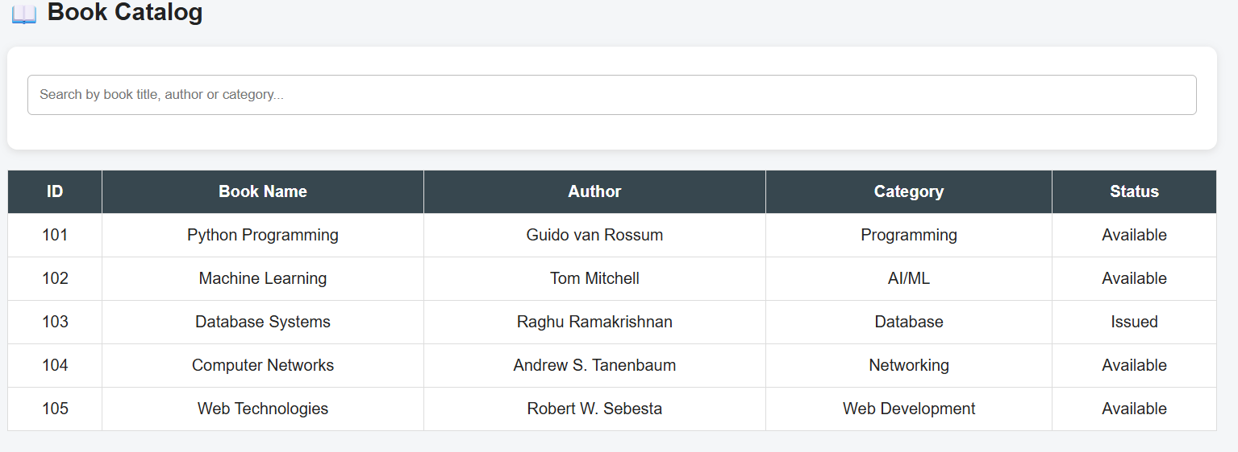
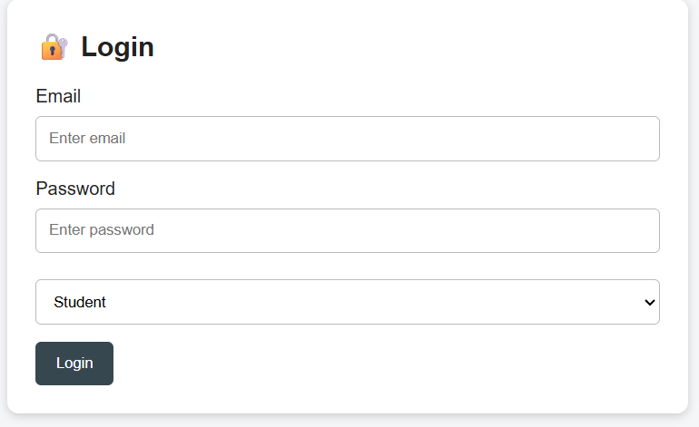

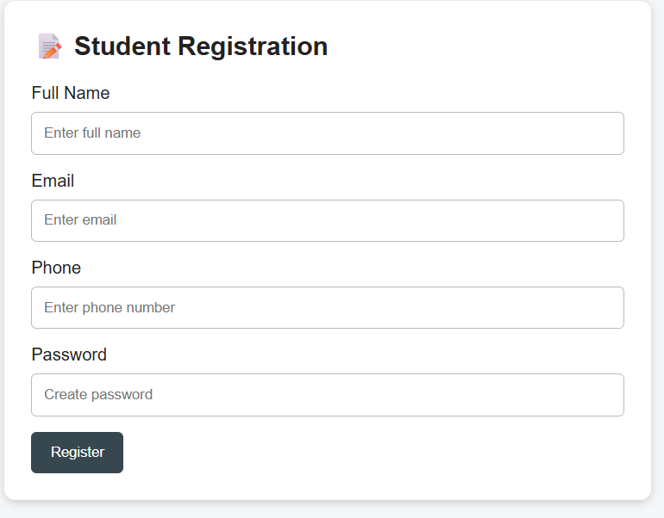
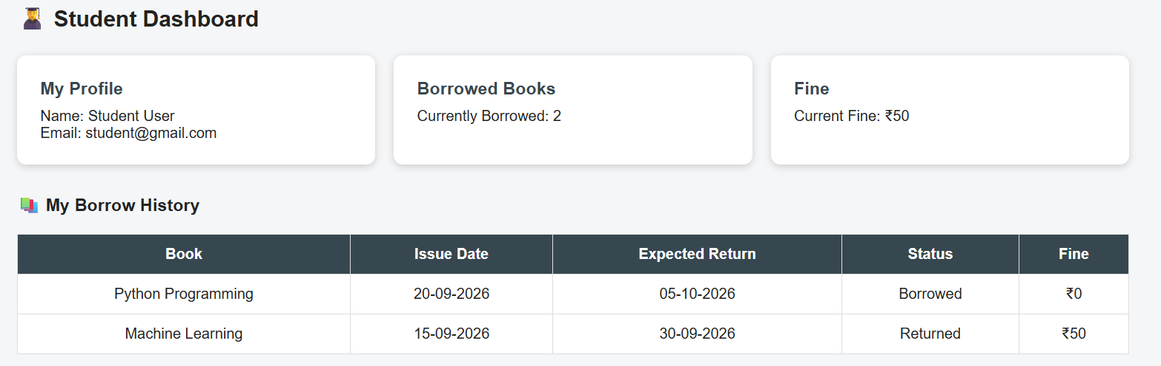
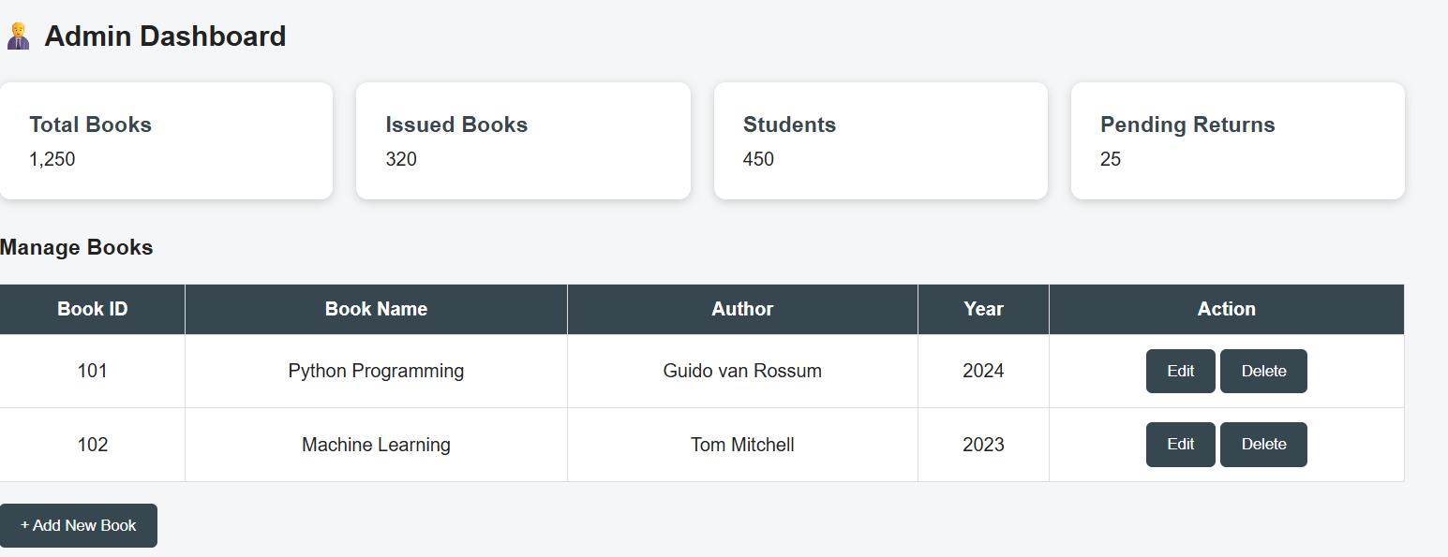
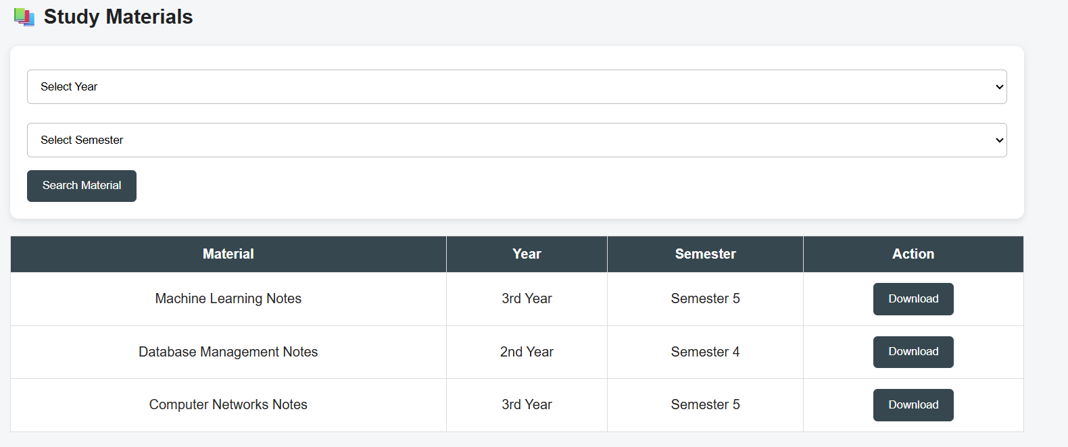

Result : Online Library Management System successfully designed

